**Supplementary material**

*AFM image*

The topographical analysis was performed using an Atomic Force Microscope (AFM) Park NX-10 model (Park Systems, South Korea). Images in Tapping and phase-contrast modes were taken using a TESP silicon tip (Bruker, USA) with a resonance frequency of 367.5 KHz, Q quality factor equal to 201, and a spring constant of approximately 48 N/m. The study was performed at ambient conditions of relative air humidity (82%) and temperature (23 ± 2 °C). Films samples (~ 1.0 cm²) were fixed to the microscope sample holder using double-sided adhesive tape. Then, for each film three randomly chosen areas were assessed. Images of 15 µm x 15 µm with 512 x 512 pixels at a scanning rate of 0.5 Hz were acquired.

*Homogeneity of weight and BCAR content of the films*

For the determinations of weight and BCAR content homogeneity, the films were cut into three fragments of 1.0 cm2 each. These fragments were subjected to individually weighing and then the BCAR content was determined. The BCAR content in each fragment was quantified by compound extraction in methanol and subjecting it to stirring for 20 min followed by sonication for 20 min. The samples were filtered (0.22 μm) and analyzed by HPLC. The mean values of weight and BCAR content were calculated and expressed as mg/cm2.

*Fluorescence spectroscopy*

Steady-state fluorescence measurement was carried out using an F-7000 FL Spectrophotometer (Hitachi, Japan) at 25 °C. Samples were placed in a 10 mm × 10 mm × 45 mm quartz cell. The fluorescence spectra of chitosan film-forming solution (CHI), in the absence and presence of copaiba essential oil (CO), with an excitation wavelength of λ = 360 nm, were recorded in the range of 380–600 nm. Excitation and emission slits were both set at 5 nm. Fluorescence spectra were plotted using OriginPro 8.0 (Origin- Lab, USA, 2002).

**Supplementary results**



**Fig. S1.** Stress-strain curves in triplicate: (a) Blank-CSF, (b) CO-CSF-3, (c) CO-NC-CSF-3, and (d) Blank-NC-CSF-3.

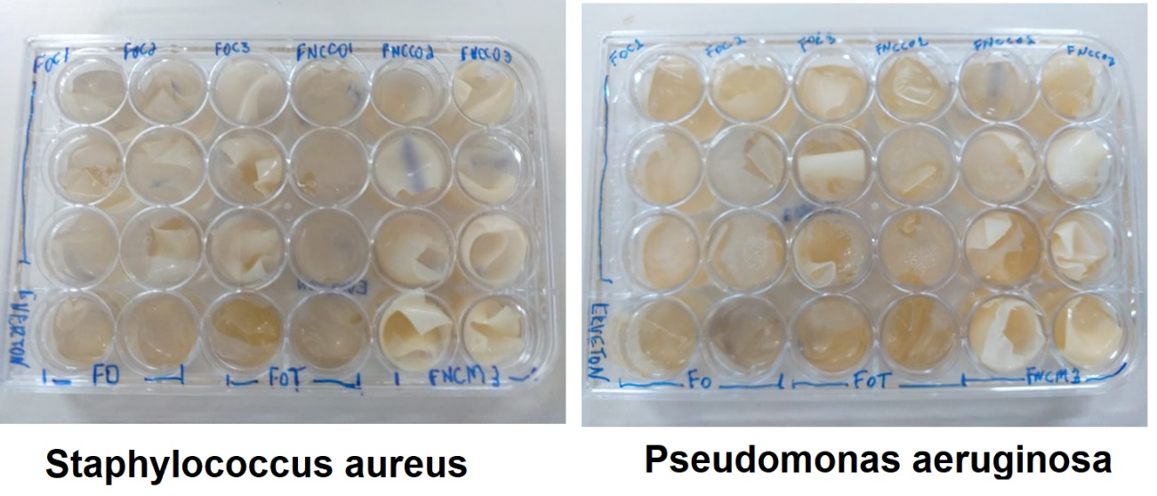

**Fig. S2.** 24-well plates after antibacterial test incubation.

**Table S1.** Analysis of variance for the mean size, polydispersion index of the NC, and physical and mechanical parameters of CS films.

|  |  |  |  |  |  |  |  |  |  |  |
| --- | --- | --- | --- | --- | --- | --- | --- | --- | --- | --- |
| Source | DF | Size* | PDI* | Size# | PDI# | DF* | Thickness | EL | TS | E |
| Mean square | 3 | 9397.3 | 0.075 | 42122 | 0.052 | 9 | 5673 | 86.3 | 1.328 | 1.640 |
| Error | 8 | 962 | 0.002 | 473 | 0.001 | 20 | 801 | 71.5 | 0.126 | 0.051 |
| Total | 11 | - | - | - | - | 29 | - | - | - | - |
| F-value | - | 9.768 | 34.44 | 89.113 | 49.13 | - | 7.08 | 1.206 | 10.55 | 32.44 |
| p-value | - | 0.005 | 0.000 | 0.000 | 0.000 | - | 0.000 | ¥0.344 | 0.000 | 0.000 |

¥No significance according to ANOVA at 5% significant level. DF: degree of freedom for the NC; DF*: degree of freedom for the CS films; PDI: polydipersion index; EL: elongation in the rupture; TS: maximum tension in the rupture; E: elastic modulus.

**Table S2.** Analysis of variance for the films’ interface properties.

|  |  |  |  |  |
| --- | --- | --- | --- | --- |
| Source | DF | θ | WVP | %Solubility |
| Mean square | 3 | 19.12 | 0.165 | 205.53 |
| Error | 8 | 0.54 | 0.019 | 7.09 |
| Total | 11 | - | - | - |
| F-value | - | 35,50 | 8.791 | 28.993 |
| p-value | - | 0.002 | 0.007 | 0.000 |

DF: degree of freedom; θ: contact angle; WVP: water vapor permeability.



**Fig. S3.** Chromatographic profile of beta-caryophyllene (BCAR) (a) and standard curve 1 (b) and 2 (c). (n = 3).



**Fig. S4.** 2D AFM images of chitosan films in different surface regions: (a) Blank-CSF, (b) CO-CSF-3, (c) CO-NC-CSF-3, and (d) Blank-NC-CSF -3

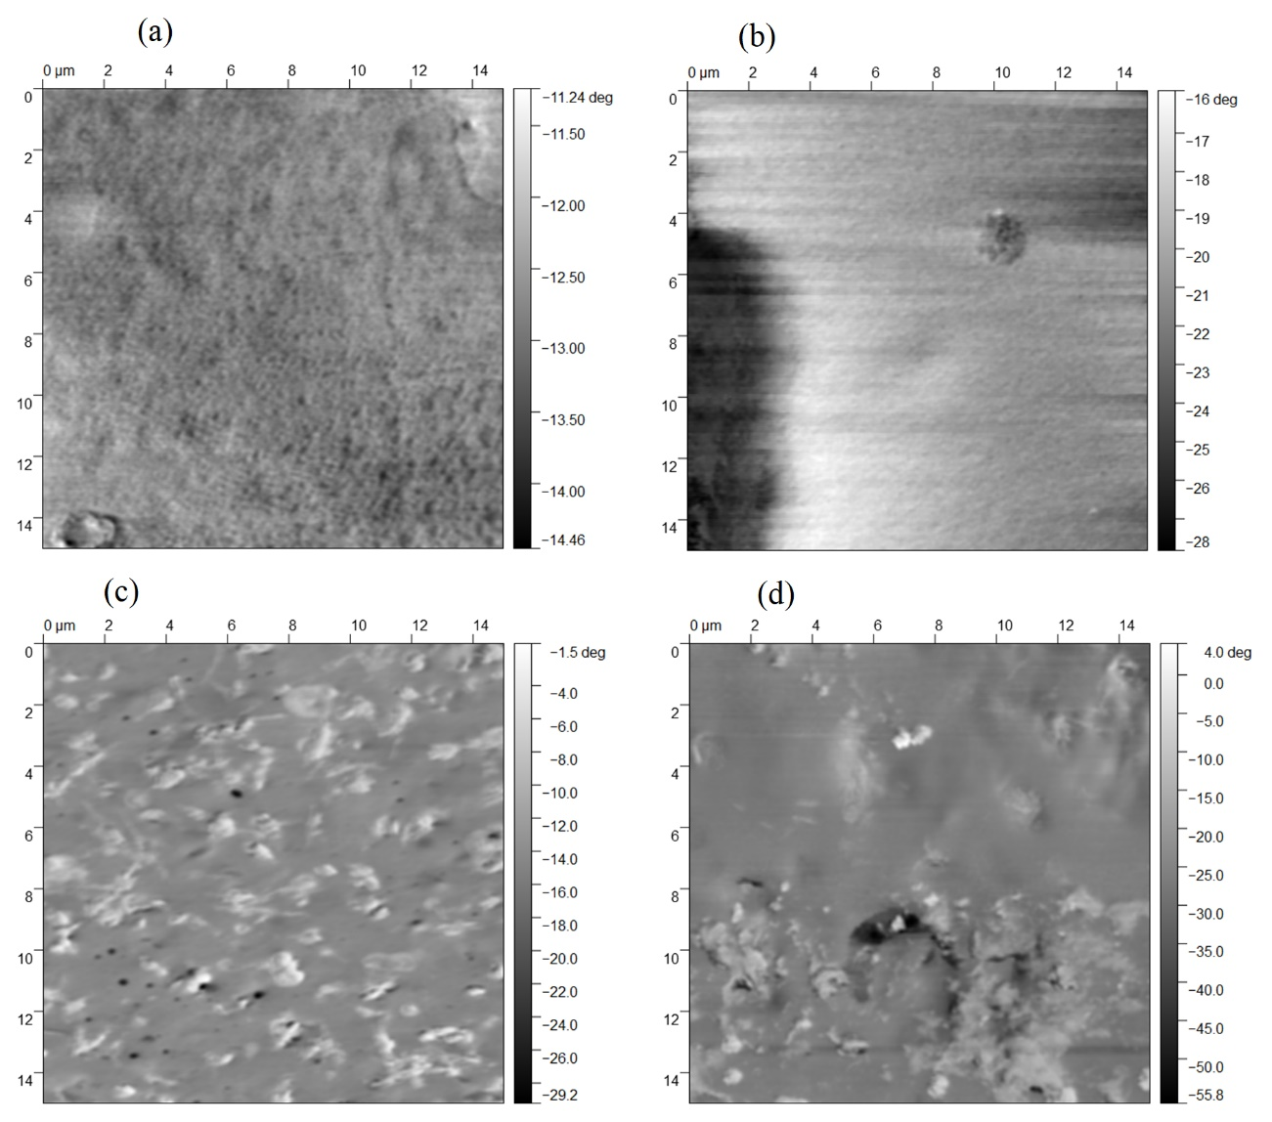

**Fig. S5.** 2D phase-contrast by AFM: (a) Blank-CSF, (b) CO-CSF-3, (c) CO-NC-CSF-3, and (d) Blank-NC-CSF-3.



**Fig. S6.** Changes in permeation cell mass plotted as a function of time: (a) Blank-CSF, (b) CO-CSF 3, (c) CO-NC-CSF 3, and (d) Blank-CSF 3. (n = 3).



**Fig. S7.** Fluorescence spectra of chitosan film-forming solution (CHI) in the absence and presence of copaiba essential oil (CO).

**Supplementary discussion**

Figs. S2 and S3 show a comparison among the topography and the phase-contrast images of CO-CSF-3, CO-NC-CSF-3, Blank-CSF, and Blank-NC-CSF-3. Phase-contrast image is used to detect and quantify changes in composition across polymer nanocomposites (Scott & Bhushan, 2003). The technique takes advantage of the contrast in viscoelastic (viscous energy dissipation) properties of the different materials across the surface. Phase images can be used to identify regions with different properties, such as adhesive, viscoelastic, stiff, or frictional, which might be hidden in the topography image (Phani et al., 2021). Polymers are found to display viscoelastic behavior (Scott & Bhushan, 2003).

Fig. S2 clearly shows that evaluated films have completely different nanotextures. The presence of CO and CO-NC significantly alter the CSF topography (Figs. S2a-c). Fig. S2b shows a region close to a pore generated by an oil droplet, which agreed with the CO-CSF-3 morphology (Fig. 1 of paper). Phase-contrast images showed only two polymeric phases for the films containing nanocapsules (Figs. S3c and S3d). The distribution of phases in CO-NC-CSF-3 was more uniform when compared to CO-CSF-3 and Blank-NC-CSF-3, which presented an external phase composed of large agglomerates. These characteristics can be indicative of the CO-NC-CSF-3 superior stability, corroborating the size distribution, mechanical properties, and SEM data shown in the paper.

The phase image in Figs. S3c and S3d pointed out NC distribution in the film’s matrix. The dark areas represent regions with a low phase shift (around -30° and -55°). The light areas indicate a much higher phase shift (around -1.5° and 4°) and are associated with the NC polymeric wall. This behavior was verified because PCL properties are very different than chitosan matrix ones. On the other hand, phase images in Figs. S3a and S3b do not show a significant phase difference between dark and light areas.

The interaction between chitosan (CHI) and copaiba essential oil (CO) was confirmed by fluorescence spectroscopy (Fig. S7). The CHI showed a characteristic fluorescence at 435 nm when excited at 360 nm. Recently, macromolecules containing only auxochromes (aliphatic amines, carbonyl groups, ester groups, and amides) have been shown to emit fluorescence under appropriate conditions (Tomalia et al., 2019; Dong et al., 2020).

In this context, the interaction of CHI with CO was monitored by the alterations in the intrinsic fluorescence of CHI in the presence and absence of CO. When CO was added, the maximum emission peak of CHI decreased, which could indicate a hydrophobic binding of CO with the hydrophobic groups of CHI resulting in a fluorescence decline (Fig. S7) (Zhang et al., 2021), corroborating with the FTIR spectra and mechanical properties presented in the paper.

**References**

Dong, Z., Cui, H., Wang, Y., Wang, C., Li, Y., & Wang, C. (2020). Biocompatible AIE material from natural resources: Chitosan and its multifunctional applications. *Carbohydr Polym*, 227, 115338.

Phani, A., Jung, H. S., & Kim, S. (2021). Deconvolution of dissipative pathways for the interpretation of tapping-mode atomic force microscopy from phase-contrast. *Communications Physics*, 4(1).

Scott, W. (2003). Use of phase imaging in atomic force microscopy for measurement of viscoelastic contrast in polymer nanocomposites and molecularly thick lubricant films. *Ultramicroscopy*, 97(1-4), 151-169.

Tomalia, D. A., Klajnert-Maculewicz, B., Johnson, K. A. M., Brinkman, H. F., Janaszewska, A., & Hedstrand, D. M. (2019). Non-traditional intrinsic luminescence: inexplicable blue fluorescence observed for dendrimers, macromolecules and small molecular structures lacking traditional/conventional luminophores. *Progress in Polymer Science*, 90, 35-117.

Zhang, X., Ismail, B. B., Cheng, H., Jin, T. Z., Qian, M., Arabi, S. A., Guo, M. (2021). Emerging chitosan-essential oil films and coatings for food preservation - A review of advances and applications. *Carbohydr Polym*, 273, 118616.